

COMPUTER SCIENCE STAGE 3 SAMPLE EXAMINATION

Section 7 of the New WACE Manual: General Information 2006–2009 outlines the policy on WACE examinations.

Further information about the WACE Examinations policy can be accessed from the Curriculum Council website at http://newwace.curriculum.wa.edu.au/pages/about_wace_manual.asp.

The purpose for providing a sample examination is to provide teachers with an example of how the course will be examined. Further finetuning will be made to this sample in 2007 by the examination panel following consultation with teachers, measurement specialists and advice from the Assessment, Review and Moderation (ARM) panel.
0000.doc




Western Australian Certificate of Education, Sample External Examination
Question/Answer Booklet

COMPUTER SCIENCE
Please place your student identification label in this box
WRITTEN PAPER
STAGE 3

Student Number: In figures

In words

Time allowed for this paper
Reading time before commencing work: Ten minutes
Working time: Three hours

Material required/recommended for this paper
To be provided by the supervisor
This Question/Answer Booklet
USB flash drive or CD with necessary resources
One Computer

To be provided by the candidate
Standard Items: Pens, pencils, eraser or correction fluid, ruler.
Special Items: Mathematical and/or system templates.
Non-programmable calculators may be used.

Important note to candidates
No other items may be taken into the examination room. It is your responsibility to ensure that you do not have any unauthorised notes or other items of a non-personal nature in the examination room. If you have any unauthorised material with you, hand it to the supervisor before reading any further.

Structure of this paper

Section | Suggested working time | Number of questions available | Number of questions to be attempted | Marks available
Section 1:  Written | 90 minutes | 20 | ALL | 60
Section 2:  Computer-based | 90 minutes | 3 | ALL | 40
 |  |  | [Total marks] | 100

Instructions to candidates
- The usual rules for the conduct of examinations apply to this examination. Note especially there is to be no talking whatsoever to any other candidate. The penalty for breach of any of the rules may include immediate on-the-spot cancellation of the examination script.

- Answer the questions according to these specifications:

SECTION 1 Write your answers in the spaces following each question.
SECTION 2: Use the computer provided to answer the required questions.

- An extra page for answering or making rough notes is available at the back of this booklet.
- Clearly label any answers on the extra page at the end of the booklet.

- It is strongly recommended that you do not use pencil except in diagrams.

- Space provided for an answer does not necessarily indicate the proper length of the answer.

SECTION 1—WRITTEN QUESTIONS

Answer all questions in the spaces provided [60 marks].

Question 1
You are developing a backup and recovery plan for a small business and have decided to investigate the option of Internet-based backup and archiving. Using such a service means that the business would send a copy of all its data files over the Internet for backup storage.

Apart from the cost, discuss two important factors that should be investigated before signing up for an Internet-based backup service.
[From: Victorian Curriculum and Assessment Authority, 2005] [2 marks]

Question 2
A user has reported that nothing appears on the screen when they type on the computer keyboard. Describe what you would do to determine if the keyboard is the problem.
[1 mark]

Question 3
- What does a modem do?
[1 mark]

- Describe how a router can help make a large network run more efficiently.
[From: Victorian Curriculum and Assessment Authority, 2006] [1 mark]

Question 4
A network operating system can provide administrators with the ability to control levels of access to the file server. Outline why an administrator would make use of this capability.
[From: Victorian Curriculum and Assessment Authority, 2005] [1 mark]

Question 5
Provide an example of a device that uses an embedded operating system. Explain how an embedded operating system differs from an operating system (such as Windows or Mac OS) found on a personal computer.
[2 marks]

Question 6
A payroll system could be implemented as either a real-time or batch transaction processing system.
- Explain how a transaction would be processed in a real-time system.
[1 mark]

- Explain why a batch transaction processing system is appropriate for a payroll system.
[1 mark]

Question 7
To successfully network computers a protocol must be used. Explain how a protocol makes networking possible.
[From: Victorian Curriculum and Assessment Authority, 2005] [1 mark]

Question 8
- Explain the difference between data mining and a data warehouse.
[1 mark]

- Explain how data mining can be used in conjunction with a data warehouse.
[1 mark]

Question 9
- A packet sniffer, also known as a network monitor or network analyser, captures all the packets of data that pass through a given network interface.

Describe one valid reason for using a packet sniffer.
[1 mark]

- Describe one inappropriate use for a packet sniffer.
[1 mark]

- Explain how encryption can be used to protect against packet sniffers.
[1 mark]

Question 10
Complete the statements following with the appropriate term from this list.
- system support documentation
- parallel conversion
- cost
- usability
- partial conversion
- project management
- testing techniques
- database modelling

[2 marks]
i. ___________________ could be tested when evaluating the performance of a system.
ii. ___________________ is used to monitor tasks and assign resources.
iii. ___________________ is a method used when implementing a new system.
iv. ___________________ is used when designing a new system.
[Adapted from: Victorian Curriculum and Assessment Authority, 2005]

Question 11
Briefly explain the use of the Rapid Application Development (RAD) method when developing systems.
[From: Victorian Curriculum and Assessment Authority, 2007] [1 mark]

Question 12
A company located in a Bunbury, a large West Australian regional town, wants to set up a global online purchasing website. A local Internet service provider (ISP) can host this website for $40 per month. Another ISP, located in India, is offering a similar service for $30 per month.

Outline three factors that should be considered before an ISP is selected.
[From: Victorian Curriculum and Assessment Authority, 2005] [2 marks]

Question 13
The following statements are contained in a large insurance company’s privacy document which is sent to all clients annually when they are sent a bill to renew their policy:

YOUR PERSONAL INFORMATION
Personal information held by us may include your name and contact details which are collected by us so we can contact you.
DISCLOSURE OF YOUR PERSONAL INFORMATION
We rely on third party suppliers (agents, legal advisers, other insurance companies and mailhouses) to perform specialised activities for us.
Your personal information may be provided to them so that they may carry out their agreed activities.

Explain, in relation to privacy legislation, why the document is sent to clients and the reasons for including the above statements.
[From: Victorian Curriculum and Assessment Authority, 2005] [3 marks]

Question 14
Swap Songs with Strangers

For copyright reasons this excerpt cannot be reproduced in the online version of this document, but may be viewed at http://technology.newscientist.com/channel/tech/mg18925335.300-mp3-players-swap-songs-with-strangers.html.

Excerpt from New Scientist p. 19, 7 January 2006

- If the Australian Government allowed this new software package to be used, identify the legislation that would be breached.
[1 mark]

- Identify and explain one ethical issue associated with using this new software package.
[1 mark]

[From: Victorian Curriculum and Assessment Authority, 2006]

Question 15
Explain why large organisations use RAID storage for their data.
[1 mark]

Question 16
Explain how the following are used in structured programming. Do not just define the terms.
- stub
- parameter
[2 marks]

Question 17
An electronic customer file is currently organised in the following way

Customer | Address | Phone | Pet 1 | Pet 2 | Pet 3
Jan Appleby | 35 Smith St West Perth | 9298 3467 | Ebony
Bill Owen | 14 Railway Pde Bayswater | 08 9453 4563 | Flossie | Fido | Tweety
Kim Anderson | 215 Barnes Ave Cottesloe | 9313 1329 | Bessie | Molly

- Suggest two changes to the design that would make this table more efficient for staff wanting to look up customer details.
[From: Victorian Curriculum and Assessment Authority, 2005] [2 marks]

- Normalise the data in this table to 3NF (Third Normal Form)
[2 marks]

Question 18
Consider the Australian library portal shown below:

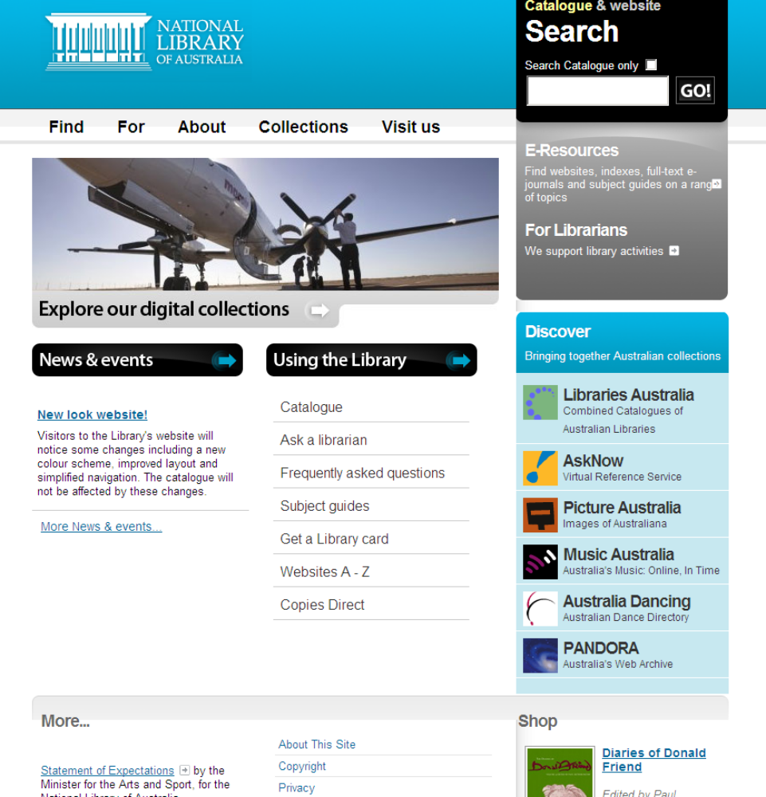

Using examples from the portal shown above, explain two advantages of using a portal.
[2 marks]

Question 19
Consider a database which keeps track of geographical information – countries and their capitals, continents, oceans, mountains and rivers. Construct an Entity Relationship Diagram (ERD) for this database taking into consideration the following information:

- Each country has a name, population, capital and exists on one continent.
- Each continent has a name, size and contains one or more countries. One or more oceans border each continent.
- Each ocean has a name, size and maximum known depth. An ocean borders one or more continents
- Each mountain has a name, height and exists in only one country.
- Each river has a name and length and flows through one continent to a single ocean

  - Draw an E-R diagram to represent the database design. Show all tables and their attributes (primary and foreign keys and non-key attributes) and underline the primary keys. Mark the foreign keys with the code ‘fk’.
[6 marks]

The data dictionary shown below was developed to show users the fields to be included in the table called ‘Country’.

Field name | Type | Length | Description
CountryName | Text | 25 | Name of the country
Continent | Text | 15 | Continent in which the country is situated
BirthRate | Text | 6 | Percentage value of the birth rate in the country
DeathRate | Text | 6 | Percentage value of the death rate in the country
LifeExpectancy | Text | 6 | Expected life span of the male population
Language | Text | 10 | Language spoken by most of the population

  - Using the data dictionary, construct an SQL command that would display the names of countries in the continent of South America where most of the population speak Spanish.
[2 marks]

  - After seeing the data dictionary, a user would like to be able to:
- calculate the rate of population increase using the fields BirthRate and DeathRate;
- store information about the expected life span of the female population.

Explain the changes that would have to be made to the data dictionary to best meet the user’s needs.
[3 marks]
[From: Board of Studies New South Wales, 2006]

Question 20
Read the information provided in the case study.
Case study
Lucy is the owner of Lucky Orchids which specialises in growing orchids for the pot plant market.

Lucy’s current system
Her nursery, a 600 square metre heated greenhouse, is located next to her house. The greenhouse is divided into three rooms that have different growing conditions for different stages of a plant’s life. Each room has its own set of climate control units that can be set according to the needs of the plants in that room. Lucy can only check each unit by going into the greenhouse and reading the climate gauges in each room.

On a recent trip to Holland, to purchase new varieties of plants, she noted that Dutch nurseries were using a computer system to monitor and control the climate in their greenhouses. Having all the sensors and climate control devices connected to a computer allowed them to grow plants from seedling to flowering in a much shorter time.

Lucy’s new system
Lucy recently has purchased a new nursery five kilometres from her house. Her new greenhouses will have to be upgraded for her orchids, so Lucy has decided that she wants to introduce a computer controlled climate system into both her existing local nursery and her new remote nursery.

She would like this computer climate control system to
- combine control of all climate devices to produce better conditions for orchid growth
- allow her to remotely check and alter the conditions in each greenhouse room in both nurseries
- record errors and send an alert message to her mobile phone if something fails.

Lucy has decided she needs some help to introduce her new computer climate control system for her greenhouses. She employs a system analyst, Susan, and outlines her current system and what she would like to achieve with the new system.
Proposed plan for the two nurseries
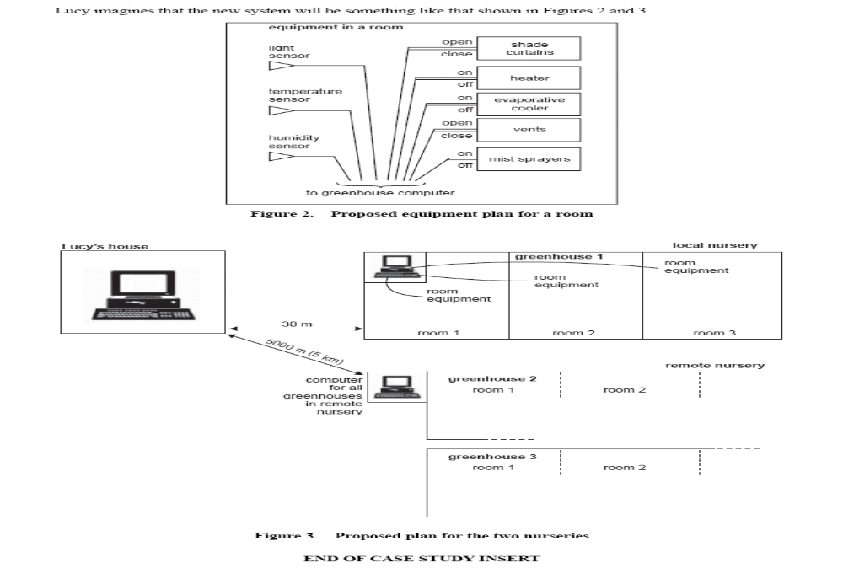
Question 20 (a)
Susan has discovered a shareware program on the Internet that appears to suit Lucy’s needs. The program uses a number of standard interface screens that will allow Lucy to make adjustments to the conditions in the greenhouses. The following screen is a typical data entry screen.

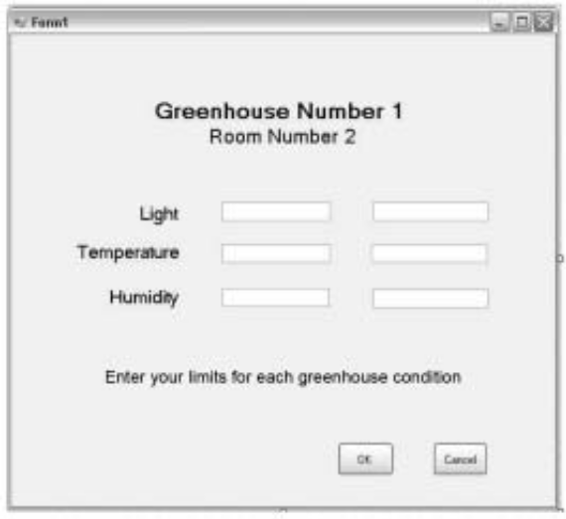

Lucy thinks that this screen has a major design fault. Identify this fault and suggest how the fault can be corrected.
[1 mark]

Question 20 (b)
Lucy has decided against the shareware program and buys the Dutch software. After installing it, her friend Peter, who is a programmer, is convinced that the Dutch software has some major faults. He has offered to fix these problems for Lucy, free of charge.

Explain one legal obligation and one ethical consideration that Lucy should think about before she accepts or rejects Peter’s offer to alter the program code.
[2 marks]

Question 20 (c)
Susan has created a PERT chart to help manage the project. A section of the chart is shown below.
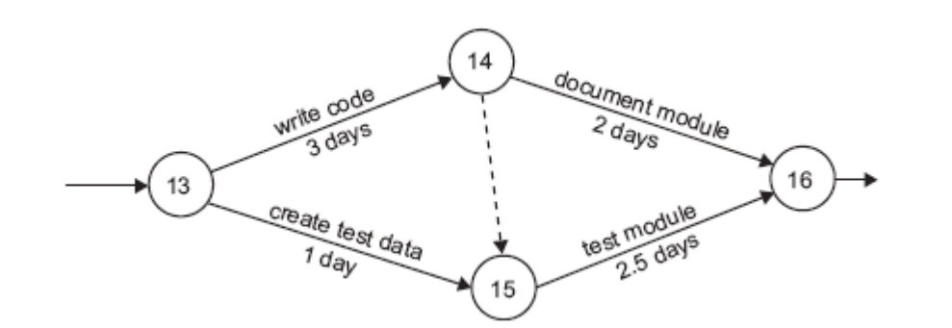
Use this chart to answer the following:

i. Identify two tasks that can be performed at the same time.
[1 mark]

ii. What is the minimum number of days in which this section of the project can be completed?
[1 mark]

[From: Victorian Curriculum and Assessment Authority, 2005]

Question 20 (d)
The new system requires a computer in each nursery to control the greenhouse climates. The orchids may be damaged if these computers fail to work. Each computer will be placed in a small enclosed area as shown in Proposed plan for the two nurseries.

List one hazard to which these computers will be exposed and describe how Lucy should protect the computers from this hazard.
[1 mark]

Question 20 (e)
Lucy wishes to connect a computer in her local nursery with a computer in her house so she can monitor the greenhouse from her study. The distance is approximately 30 metres. She has two choices:

- Option 1: to connect via CAT-5 cable
- Option 2: to set up a wireless link

Select the better option for Lucy. Justify your selection by comparing the two options.
[2 marks]

Question 20 (f)
Over the last five years Lucy and a team of researchers from the University of Western Australia have been experimenting with hybrid orchids attempting to develop new flower colours.

Susan’s level 1 data flow diagram represents the recording and analysing of research data that she has observed and is described below.

Experimenter
colour tallies
1
enter daily tallies
Daily colour tallies
colour tally totals
2
create daily reports
colour tally totals
Daily reports
Hybrid master file
hybrid flower details
daily report details
hybrid flower details
The Orchid Place
Singapore weekly colour tallies
Paradise Orchids
3
Create weekly report
overseas flower details
UWA
hybrid colour weekly results
Taiwan weekly colour tallies
hybrid flower details
hybrid flower statistics

Experimenters record flower colours for new hybrids using handwritten tally sheets. After observations have been completed, each of the experimenters keys in tally totals on the computer in the green house for later analysis.

At the end of each day, Lucy runs a program that uses the colour tally totals and the hybrid flower details from the hybrid master file to create a daily experiment report. An electronic copy of the report is stored in the Daily reports file.

Similar experiments are being conducted at two other nurseries, The Orchid Place in Singapore and Paradise Orchids in Taiwan. The results from these sites are emailed to Lucy once a week. Lucy runs a program to enter the overseas hybrid flower results into the hybrid master file. When all the overseas results have been entered Lucy uses the program to calculate statistics for the week’s experiments. These statistics are saved in the Hybrid master file. The word processed hybrid colour weekly report is then prepared by including the statistics from the Hybrid master file and comments that Lucy adds. This report is emailed to the researchers at UWA.

[Adapted from: Victorian Curriculum and Assessment Authority, 2006]
Draw a level 2 data flow diagram to expand process 3.
[6 marks]

END OF SECTION ONE

SECTION 2—COMPUTER-BASED QUESTIONS

Locate all required materials from electronic media provided.
Answer all questions [40 marks].

Part A—Database questions [20 marks]

Question 21
The Astro Hockey Club Database
The Astro Hockey Club wants to record details about teams and the equipment kits they have been allocated for the season.

Open the database file AstroHockey.mdb
Using the tables (see below) in the AstroHockey.mdb database complete the following tasks:

tblCoaches
CoachID | Surname | Firstname | Street | Suburb | Postcode | fCoachRating
1 | Cropper | John | 911 Millgate Road | SPORTSVILLE | 6108
2 | Eggleston | George | 6 Stedman Street | CROSSPATCH | 6149
3 | Green | Hannah | 117 Stanley Loop | KINGSTON | 6009
4 | Hill | John | 316 Gratwick Drive | SPORTSVILLE | 6108
5 | Jones | Margaret | 910 Downsborough Street | KEWDALE | 6105
6 | Mackrie | James | 516 First Ave | CLIFTON BEACH | 6076
7 | Morley | Joseph | 915 Voyager Way | SPORTSVILLE | 6108
8 | Parry | Sarah | 5 Grigo Ave | SPRINGVALE | 6169
9 | Richardson | James | 914 Carlow Circle | WILBURY | 6152
10 | Smith | Thomas | 6 Samson Drive | FRAMTON | 6160
11 | Todd | Nicholas | 917 Carissa Court | MERRIVALE | 6058

tblEquipAllocations
KitAllocationID | fTeamID | fEquipKitID | DateTaken | DateReturned | Deposit
1 | 1 | 1 | 8/04/2001 | 31/05/2001 | 15
2 | 1 | 6 | 19/04/2001 | 31/05/2001 | 15
3 | 3 | 5 | 8/04/2001 | 10/04/2001 | 30
4 | 4 | 2 | 9/04/2001 |  | 15
5 | 4 | 7 | 27/04/2001 |  | 15
6 | 6 | 1 | 3/06/2001 |  | 15
7 | 3 | 5 | 6/05/2001 | 7/05/2001 | 30
8 | 2 | 7 | 12/05/2001 | 13/05/2001 | 15
9 | 2 | 3 | 13/05/2001 | 15/05/2001 | 15

tblEquipKits
EquipKitID | Kit Code | Description | SuggestedDeposit
1 | JSS01 | Junior Stick Set 1 | 15
2 | JSS02 | Junior Stick Set 2 | 15
3 | JSS03 | Junior Stick Set 3 | 15
4 | SSS01 | Senior Stick Set 1 | 30
5 | SSS02 | Senior Stick Set 2 | 30
6 | JGG01 | Junior Goalie Gear 1 | 15
7 | JGG02 | Junior Goalie Gear 2 | 15

tblManagerAllocations
ManagerAllocationID | fTeamID | fManagerID | Season | DateStarted | DateEnded
1 | 1 | 1 | Winter 2001 | 1/04/2001
2 | 2 | 2 | Winter 2001 | 1/04/2001
3 | 3 | 3 | Winter 2001 | 1/04/2001
4 | 4 | 4 | Winter 2001 | 1/04/2001
5 | 5 | 5 | Winter 2001 | 12/04/2001
6 | 6 | 1 | Winter 2001 | 15/04/2001

tblManagers
ManagerID | Surname | Firstname | Phone
1 | Jones | Sue | 9376 1234
2 | Wright | Andrew | 9275 1588
3 | Case | Bob | 9477 7631
4 | Green | Michael | 9578 9012
5 | Pearson | Jill | 9475 3198
6 | Jones | Sue | 9376 1234

tblTeams
TeamID | TeamName
1 | Bulldogs Boys U12A
2 | Jets Boys U12B
3 | Tigers Vets
4 | Apollo Girls U12C
5 | Jets Girls U14A
6 | Bulldogs Boys U14B

Question 21(a)
Create the necessary relationships between the six tables provided. You may need to create an additional table. Be sure to enforce referential integrity for each relationship.
[5 marks]

Question 21(b)
i. Open the table tblEquipKits.
  - Create a rule to ensure that the SuggestedDeposit must be greater than zero.
  - The SuggestedDeposit field utilises the data type Number - Byte. Choose a more appropriate data type for this field.

Save and close the table tblEquipKits.

ii. Open the table tblEquipAllocations.
- Change the fTeamID field to a lookup field that displays a combo box with the source tblTeams. Set the properties so that the name of the team is displayed when the table is viewed in datasheet view.
- Make similar changes to the fEquipKitID field.

Save and close the table tblEquipAllocations.
[5 marks]

Question 22
The Astro Hockey Club Database
Create the following queries in the Astro Hockey Club database:

- A query that lists the Firstname, Surname and Suburb of all coaches who have a postcode beginning with 61. Sort the Surname field alphabetically.

Save the query as qryPostcode
[1 mark]

- A query that lists the manager phone numbers and names in a combined field called Fullname (eg John Smith).

Save the query as qryFullname
[2 marks]

- An update query that increases the SuggestedDeposit in tblEquipKits by $5.

Save the query as qryIncreaseDeposit
[1 mark]

- A delete query that will delete the coaches who live in Sportsville from tblCoaches.

Save the query as qryDeleteCoaches
[1 mark]

- A query that shows the kit code, description and date taken of all equipment kits that have not been returned.

Save the query as qryEquipNotReturned
[2 marks]

- A parameter query that prompts the user to enter a start date and a finish date for the DateTaken in tblEquipAllocations. Show the TeamName, KitCode, Description, DateTaken and Deposit of all equipment kits taken within the date range.

Save the query as qryEquipDateRange
[3 marks]

Part B—Programming questions [20 marks]

Answer all questions in this section.

Question 23
Load the code for “Program1”. The algorithm, Module Main, for this program is provided below. This single program module carries out several tasks.

Module Main

Input(VehicleType)
Input(NetPrice)

Case VehicleType of
"Sedan" : HandlingFee ← NetPrice * 0.1
"Ute" : HandlingFee ← NetPrice * 0.1
"4WD" : HandlingFee ← NetPrice * 0.2
"Van" : HandlingFee ← NetPrice * 0.2
End Case

Case NetPrice
< 35001 : SubTotal ← NetPrice + ((NetPrice * 2.5) / 100)
>= 35000 And NetPrice <= 45000 : SubTotal = NetPrice + ((NetPrice * 4) / 100)
> 45000 : SubTotal = NetPrice + ((NetPrice * 5) / 100)
End Case

SubTotal = SubTotal + HandlingFee
GrossPrice = SubTotal * 1.1
Output(GrossPrice)

If GrossPrice > 20000 Then
Output ("Free bonus car mats, are availabe with this vehicle!")
End If

End Main

- Study the algorithm and read the comments in the code module to determine how the module functions. Good modular programming practice ensures that
  - a module performs a single task
  - parameters are used to pass data in and out of modules

Improve this program by dividing this module into a series of modules. Use the current existing module to call the other modules and for user input and output.

Save your changes to “Program 1”.
[12 marks]

- A function is a special type of module that returns a single value. Create a function to calculate the final amount owed after a trade-in vehicle value entered by the user. The amount should be calculated after the GST is calculated.

Modify the existing code to make use of this function.
[4 marks]
Question 24
Write the code for a program that will store the numbers 1 to 10 in an array called Numlist.

The program should output these numbers in reverse order from 10 to 1.

Save your program as “Program 2”
[4 marks]

END OF PAPER
ACKNOWLEDGEMENTS

Question 1: Adapted from: Victorian Curriculum and Assessment Authority. (2005). Information Systems: Written examination: Victorian Certificate of Education 2005 (p. 20). Retrieved August, 2007, from http://www.vcaa.vic.edu.au/vce/studies/infotech/infosystems/pastexams/2005infosys.pdf.
© VCAA

Question 3b: Victorian Curriculum and Assessment Authority. (2006). Information Systems: Written examination: Victorian Certificate of Education 2006 (p. 6). Retrieved August, 2007, from http://www.vcaa.vic.edu.au/vce/studies/infotech/infosystems/pastexams/2006infosys-w.pdf.
© VCAA

Question 4: Victorian Curriculum and Assessment Authority. (2005). Information Systems: Written examination: Victorian Certificate of Education 2005 (p. 4). Retrieved August, 2007, from http://www.vcaa.vic.edu.au/vce/studies/infotech/infosystems/pastexams/2005infosys.pdf.
© VCAA

Question 7: Adapted from: Victorian Curriculum and Assessment Authority. (2005). Information Systems: Written examination: Victorian Certificate of Education 2005 (p. 5). Retrieved August, 2007, from http://www.vcaa.vic.edu.au/vce/studies/infotech/infosystems/pastexams/2005infosys.pdf.
© VCAA

Question 10: Adapted from: Victorian Curriculum and Assessment Authority. (2005). Information Systems: Written examination: Victorian Certificate of Education 2005 (p. 2). Retrieved August, 2007, from http://www.vcaa.vic.edu.au/vce/studies/infotech/infosystems/pastexams/2005infosys.pdf.
© VCAA

Question 11: Victorian Curriculum and Assessment Authority. (2007). Information Technology: Software Development 2007–2010: Written examination—end of year (p. 11). Retrieved August, 2007, from http://www.vcaa.vic.edu.au/vce/studies/infotech/softwaredevel/2007_softwaredev_sample.pdf.
© VCAA

Question 12: Adapted from: Victorian Curriculum and Assessment Authority. (2005). Information Systems: Written examination: Victorian Certificate of Education 2005 (p. 3). Retrieved August, 2007, from http://www.vcaa.vic.edu.au/vce/studies/infotech/infosystems/pastexams/2005infosys.pdf.
© VCAA

Question 13: Victorian Curriculum and Assessment Authority. (2005). Information Processing and Management: Written examination: Victorian Certificate of Education 2005 (p. 13). Retrieved August, 2007, from http://www.vcaa.vic.edu.au/vce/studies/infotech/infoprocess/pastexams/2005ipm.pdf.
© VCAA

Question 14: MP3 players swap songs with strangers. (2006, January 7). New Scientist, 2533.

Victorian Curriculum and Assessment Authority. (2006). Information Processing and Management: Written examination: Victorian Certificate of Education 2006 (p. 15). Retrieved August, 2007, from http://www.vcaa.vic.edu.au/vce/studies/infotech/infoprocess/pastexams/2006IPM-w.pdf.
© VCAA

Question 17: Adapted from: Victorian Curriculum and Assessment Authority. (2005). Information Processing and Management: Written examination: Victorian Certificate of Education 2005 (p. 8). Retrieved August, 2007, from http://www.vcaa.vic.edu.au/vce/studies/infotech/infoprocess/pastexams/2005ipm.pdf.
Published by the Curriculum Council of Western Australia
27 Walters Drive
OSBORNE PARK WA 6017
© VCAA

Question 18: National Library of Australia. (2007). [Home page]. Retrieved July, 2007, from http://www.nla.gov.au/.

Question 19: Board of Studies New South Wales. (2006). Information Processes and Technology: 2006 Higher School Certificate Examination (p. 12). Retrieved August, 2007, from http://www.boardofstudies.nsw.edu.au/hsc_exams/hsc2006exams/pdf_doc/info_process_tech_06.pdf.
© Board of Studies NSW for and on behalf of the Crown in right of the State of New South Wales

Question 20: Adapted from: Victorian Curriculum and Assessment Authority. (2006). Information Systems: Written examination: Victorian Certificate of Education 2006 (pp. 7, 10). Retrieved August, 2007, from http://www.vcaa.vic.edu.au/vce/studies/infotech/infosystems/pastexams/2006infosys-w.pdf.
© VCAA

Question 20c: Adapted from: Victorian Curriculum and Assessment Authority. (2005). Information Systems: Written examination: Victorian Certificate of Education 2005 (p. 5). Retrieved August, 2007, from http://www.vcaa.vic.edu.au/vce/studies/infotech/infosystems/pastexams/2005infosys.pdf.
© VCAA

